**实验10 双链路冷备配置**

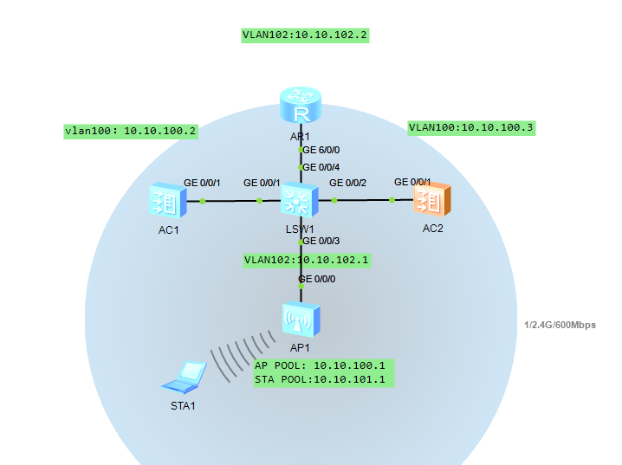

AC1基础配置

<AC6005>sys

Enter system view, return user view with Ctrl+Z.

[AC6005]SYS AC1

[AC1]vlan batch 100 101

[AC1]vlan b

[AC1]vlan batch 100 101

[AC1]int vlan 100

[AC1-Vlanif100]ip add 10.10.100.2 24

[AC1-Vlanif100]int g0/0/1

[AC1-GigabitEthernet0/0/1]port link-type trunk

[AC1-GigabitEthernet0/0/1]port trunk allow-pass vlan 100 101

SW基础配置

<Huawei>sys

[Huawei]sys SW1

[SW1]VLAN batch 100 to 102

[SW1]int vlan 100

[SW1-Vlanif100]ip add 10.10.100.1 24

[SW1-Vlanif100]

[SW1-Vlanif100]

[SW1-Vlanif100]int vlan 101

[SW1-Vlanif101]ip add 10.10.101.1 24

[SW1-Vlanif101]int g0/0/1

[SW1-GigabitEthernet0/0/1]port link-type trunk

[SW1-GigabitEthernet0/0/1]port trunk allow-pass vlan 100 101

SW1-GigabitEthernet0/0/1]int g0/0/2

[SW1-GigabitEthernet0/0/2]port link-type trunk

[SW1-GigabitEthernet0/0/2]port trunk allow-pass vlan 100 101

[SW1]ip pool ap-pool

[SW1-ip-pool-ap-pool]network 10.10.100.0 mask 24

[SW1-ip-pool-ap-pool]gateway-list 10.10.100.1

[SW1-ip-pool-ap-pool]excluded-ip-address 10.10.100.2

[SW1-ip-pool-ap-pool]excluded-ip-address 10.10.100.3

[SW1-ip-pool-ap-pool]int g0/0/3

[SW1-GigabitEthernet0/0/3]port link-type trunk

[SW1-GigabitEthernet0/0/3]port trunk allow-pass vlan 100 101

[SW1-port-group-trunk]port trunk pvid vlan 100

[SW1]dhcp enable

[SW1-Vlanif1]int vlan 100

[SW1-Vlanif100]dhcp select global

[SW1]int vlan 101

[SW1-Vlanif101]dhcp select interface

[SW1-Vlanif101]

AC2基础配置

AC6005>

<AC6005>sys

[AC6005]sys AC2

[AC2]vlan batch 100 101

[AC2]int vlan 100

[AC2-Vlanif100]ip add 10.10.100.3 24

[AC2-Vlanif100]int g0/0/1

[AC2-GigabitEthernet0/0/1]port trunk allow-pass vlan 100 101

AC1

[AC1] **wlan**

[AC1-wlan-view] **ap auth-mode mac-auth**

[AC1-wlan-view] **ap-id 0 ap-mac 60de-4476-e360**

[AC1-wlan-ap-0] **ap-name area_1**

[AC1-wlan-ap-0] **ap-group ap-group1**

**[AC1]capwap source interface vlanif100**

**[AC1]wlan**

**SSID的一些配置**

ap-group name ap-group100

radio 0

vap-profile bitc wlan 1

AC2同样的配置

双链路冷备配置

[AC1-wlan-view] **ac protect protect-ac 10.23.100.3 priority 0**

[AC1-wlan-view] **ac protect enable**

Warning: This operation maybe cause AP reset, continue?[Y/N]: **y**

[AC2-wlan-view] **ac protect protect-ac 10.23.100.2 priority 1**

[AC2-wlan-view] **undo ac protect restore disable**

[AC2-wlan-view] **ac protect enable**

Warning: This operation maybe cause AP reset, continue?[Y/N]: **y**

